

DEPARTMENT OF COMPUTER SCIENCE & ENGINEERING
DRK COLLEGE OF ENGINEERING AND TECHNOLOGY
Affiliated to JNTU HYDERABAD,
Bowrampet, HYDERABAD-500043.

MINI PROJECT ON

“Development of Chronic Kidney Disease Using Ensemble Approach”

BACHELOR OF TECHNOLOGY

In

COMPUTER SCIENCE & ENGINEERING

By

N. Lohitha sai : 18U51A0543

T. Bhavani : 18U51A0562

K. Rajeshwari : 18U51A0528

P. Hanumantha Rao : 18U51A0549

Sai Nikith Reddy Yarram : 18U51A0565

Under the guidance of

Prof. (Dr) Gnaneswara Rao Nitta

TABLE OF CONTENTS

Chapter 1: INTRODUCTION 1

1.1 Motivation

1.2 Issues identified

1.3 Objective

Chapter 2: SOFTWARE REQUIREMENT SPECIFICATION

2.1 Requirement Analysis

2.2 Problem Statement

2.3 Functional Requirements

2.4 Software Requirement Specification

2.4.1 Purpose

2.4.2 Scope

2.4.3 Technologies used

2.4.4 Overview

2.4.5 Product Perspective

2.5 Software Requirements

2.6 Hardware Requirements

2.7 Functional Requirements (Modules)

2.8 Non-Functional Requirements

2.9 External Interface Requirements

2.10 Modeling

Chapter 3: PROPOSED METHODOLOGIES

3.1 Addressing issues

3.2 Proposed Methodology

Chapter 4: RESULTS AND DISCUSSION

4.1 Datasets

4.2 Tools and Languages

4.3 Performance Metrics

4.4 Discussion on Results

Chapter 5: CONCLUSION

REFERENCES

ABSTRACT

Chronic kidney disease (CKD) is a condition in the human body where kidneys are damaged and it fails to filter the waste and excess fluid from the blood or cannot filter blood as well as they should. There are no initial symptoms, later on symptoms such as leg swelling, vomiting, loss of appetite, nausea. CKD is mainly caused by diabetes, high blood pressure, hypertension. Millions of people did die due to this CKD, it is one of the substantial health crises in the world. If CKD disease is not treated, it can get worse and lead to kidney failure. That’s why it’s so important to diagnose early and accurately. The need for precise diagnosis set off the application of data mining techniques. Not long ago, data mining techniques have been subjected to covering a large area of research in CKD with prominence entirely on accuracy besides through the simplification of the CKD by performing feature selection in addition to pre-processing or not before classification. The objective of this paper is to approach two ensembles that is to say: Bagging and Random Subspace methods on three base learners K Nearest Neighbours (KNN), Naïve Bayes and Decision Tree for enhancing the classification performance of the models. Before classification, data preprocessing was accomplished to handle all the missing values and data scaling in normalising the range of independent variables.This algorithm provides better classification and prediction performance for determining severity stage in CKD. The performances of the model have been evaluated with accuracy, ROC criteria, Kappa, specificity and sensitivity. Experimental results of dataset obtained from UCI machine learning repository based on CKD shows that the ensemble techniques provide better results on individual base learners performances with random subspace having the best performance rather than bagging in most of the considered situations. By the use of random subspace ensemble technique on KNN classifiers it is ensured that prediction is 100% accurate. Therefore this model is suitable for efficient diagnosis of Chronic Kidney disease.

KEYWORDS

Chronic kidney disease (CKD)
Data mining
Bagging
Random Subspace
Naive Bayes
KNN
Decision tree
Accuracy
ROC, Kappa

.

1. Introduction

Chronic kidney disease(CKD) is a common disease among all race of the world .as a result of according to a recent survey 10% of the world population suffer and die chronic kidney disease and server million of people death annually is the shortage of treatments and lack of knowledge about chronic kidney disease an accurate diagnosis most especially in developing countries of the world where the early diagnosis and treatment of ckd will prevent it progression to kidney failure. The best way to treat ckd is to diagnose if in the early stages.but discovering if in its late stages will lead to kidney failure which requires continuous dialysis to kidney transplantation to maintain a normal life. Due to increasing number of chronic kidney patients the scarcity of specialist physicians and the high cost of diagnosis and treatment ckd is a disease that damages the pair of kidneys there by to make slow or difficult the progress of kidneys from performing their long time which affects the functioning of the urinary system.then accumulation of waste product in the blood, lead to the emergence of other health problem facing in major cause is the malfunctioning of the kidney is disposing toxins (means its positions , it make many health issues) from the blood . Which are associated with servel symptoms such as high and low blood pressure, diabetes, nerve damages, vomiting, leg swelling, breath shortness if stuffed up with fluid among others that will eventually cause loss of muscle function in part of your body. at any time the entire system resulted in death. Central for disease control and prevention afford the treatment at all this within the result death of over thirty million people in the World are leaving with ckd as at 2017 and confirmed that ninety -six percent of the having kidney challenges are not even aware. The doctor generally confirmed by definition of ckd is based on the presence of kidney damage that is albuminuria that decreases kidney function for 3 months or more. The major cause is the degeneration of the kidney that reduces the rate of GFR which describes kidney functions of less than 60mL/ min per 1.73m2 within a period of 3 months and makes decisions on the basis of their expert knowledge which sometimes may result in wrong prediction. Based on information such as age, blood, test gender, and other factors suffered by the patient regarding the GFR values, the doctor classifies ckd into five stages: it shows the different stages of kidney disease development with GFR levels .

Here classification techniques like KNN (k-nearest neighbour) ,naive bayes,, decision tree, are used by many researchers is the health care for analysis detect and predict for a diseases among there other but limited research was conducted using ensemble approach on three base- learners that are not computational intensive for fast and accurate diagnostics .this paper aim to enhance to predict ckd diagnosis accuracy using bagging and random subspace ,ensemble learning techniques it suggest that ensemble learning classifiers provide better classification performances and easy to solve problem in the dataset is preprocessed by completing and normalising the missing data the relevant features are selected from the dataset for improved accuracy and reduced training time .then applying the range of large scale to prediction using twenty five attributes available in the dataset consisting of 400 instances.the result for selected feature on the data indicate accuracy detection for ckd.it contain the various metrics used for performance evaluations are predictive accuracy mild 3 Kidney damage is moderate 30–59 4 Kidney damage is severe 15–29 5Established kidney failure≤15 ,precision, roc , sensitivity and specificity kappa statistics .the KNN classification techniques provide 100% accuracy is prediction compare to Other classifiers

1.1 Motivation

The main motivation of chronic kidney disease is lack of awareness.According to international survey in 2017, CKD resulted in 1.2 million deaths and was the 12th leading cause of death worldwide. In addition, 7.6% of all CVD deaths (1.4 million) could be attributed to impaired kidney function. Together, deaths due to CKD or to CKD-attributable accounted for 4.6% of all-cause mortality.

The burden of chronic kidney disease (CKD) in India cannot be assessed accurately. The approximate prevalence of CKD is 800 per million population (pmp), and the incidence of end-stage renal disease (ESRD) is 150–200 pmp. The most common cause of CKD in population-based studies is diabetic nephropathy.

As compared to the Indian average of 10-15 per cent, Chronic Kidney Disease of unknown aetiology (CKDu) cases Uddanam region of Andhra Pradesh shows a high incidence rate ranging between 30-45% of the population being affected. It is being found there are high incidences of CKD prevalent in that region.The Uddanam region that lies in north-coastal Andhra consists of the mandals of Kaviti, Sompeta, Kanchili, Ichapuram, Palasa and Vajrapukotturu, accounting for more than 100 villages in total. As of 2015, It was estimated that more than 4500 people had died in the last ten years, and around 34,000 people were suffering from kidney diseases in this area alone. Mainly uddanam people are affected with chronic kidney failure. It was reported that each family in the area had at least one person suffering from a kidney ailment. The cases had first mysteriously surfaced in the early 90s.Symptoms included hypertension and diabetes, followed by a long asymptomatic period, and later diagnosed with excess proteins in the urine, decreased red blood cell count and high levels of uric acid in the blood.

By considering all the issues and to reduce the death rate, this project motive has been strengthen.The main motive is to detect the CKD in early stages, by considering all the health conditions, symptoms and health attributes this project is built with predicting the CKD with the best accuracy rate.

1.2 Issues Identified

- Among Naive-bayes, Decision Tree and KNN, predicting the best classifiers with ensemble techniques.

- Data containing NaN values and inserting NaN values could be solved.

- By using PCA can visualise the reduced dimensions.

1.3 Objectives
The main objective is to predict the ckd, with the ensemble techniques.

- It is needed to build a model that can predict ckd with maximum accuracy rate.

- The time complexity for processing the data is reduced.

- The objective of this project is to show that ensemble approach gives a better prediction than individual base classifiers.

- The objective of this project is to know which approach or method is suitable for chronic kidney disease prediction.

- To improve we use KNN, naive bayes, decision tree classifiers which are a machine learning algorithm.

- The intention of this project is to help the health care centres Diagnose the chronic kidney disease in the early stages and help people treat accordingly for a healthier living.

2. Software Requirement Specification

2.1 Requirement Analysis

The main goal of this project system is to predict chronic kidney disease to develop an ensemble approach to the chronic kidney disease diagnosis with the help of machine learning techniques ensemble models .which help to predict the accurate result.

2.2 Problem Statement

Nowadays chronic kidney disease among all races of the world results in millions of deaths annually due to lack of timely and accurate diagnosis. so this project helps to detect chronic kidney disease in less time and with more accuracy.

2.3 Functional Requirements

These requirements which are related to the function aspect of software fall in this category.they define functions of functionality within and from the software systems.

2.4 Software Requirements Specification

Software requirement specification document is intended to provide the requirement of the recommender system provided the srs documents includes the project perspective data model, and constraints of the overall system, projects, patients.

2.4.1 Purpose

The main focus of this project is to develop an ensemble approach to chronic kidney disease diagnosis that is unable on early detection of chronic kidney disease using machine learning techniques algorithm also to improve the chronic kidney disease cure rate by early detection.

2.4.2 Scope

Given system describes what features are in the scope and what is not in the scope of the system to be developed. The targeted software product is a chronic kidney disease detection and classification system .The components can be implemented in the hospital management system to improve and support doctor's work.

2.4.3 Technologies Used

- Python

Python is an interpreted, high-level, general-purpose programming language. Created by Guido van Rossum and first released in 1991, Python design philosophy emphasises code reliability with its notable use of significant whitespace. Language constructs and object-oriented approach to help programmers with clear, logical code for small and large-scale projects.

Python is dynamically typed and garbage collected. It supports multiple Programming Paradigms, including procedural, Object oriented, and functional programming.Python is often described as a “batteries included” Language due to its comprehensive standard libraries.

- Jupyter Notebook

The jupyter notebook is an open-source web application that allows you to create and share documents that contain line code, equations, visualisations, common and narrative text. Uses include data cleaning and transformation, numerical simulation, statistical modelling, data visualisation, machine learning, and much more.

2.4.4 Overview

The proposed Chronic Kidney Disease with K-Nearest Neighbours, Naive Bayes and Decision tree are supervised machine learning algorithms that can be used for classification challenges employed with two ensemble approaches namely: Bagging and Random subspace methods. This results in predicting chronic kidney disease.

2.4.5 Product Perspective

The development of an approach to Chronic Kidney Disease depends on data that comes from the health reports of the patient. The development of an approach to Chronic Kidney Disease is used by the health sectors like hospitals and diagnosis centres.

Our development of an approach to Chronic Kidney Disease works on any level of implementation. The development of this approach can be embedded on diagnosis machines.

In terms of software, development of an approach to Chronic Kidney Disease will run on private computers for huge data. That is, it will run on any device with an internet connection. The system will work on both Windows and Unix operating systems.

2.5 Software Requirements

The software requirements will consist of the essential components required for project development. The developer who works on the product will get all the answers which are required for the project development. The software requirements help predict the project cost and are helpful in gathering all the tools for the project development.

The software requirements for this project are as follows:

- Operating System: Windows10

- Software Packages: python, Pandas and NumPy.

- Tools Required: Anaconda, Jupyter Notebook.

2.6 Hardware Requirements

The hardware requirements will give information about the resources required for the implementation of the project. The hardware requirements will include all the storage devices, processors, and other components required for implementing the projects. These requirements also give an idea to the developer that the specification required for the project to run without failures.

The hardware requirements for the project are as follows:

- Operating System: Windows10

- Procesor: Intel Core i5 processor

- RAM: 8 Gb

2.7 Functional Requirements

Requirements, which are related to the functional aspects of software fall into this category. They define functions and functionality within and from the ID and username.

USER:

The user is the one, who are the diagnolists who take health tests. While diagnosis, the attributes which are the parameters of the patients can check the stage of the CKD.

2.8 Non-Functional Requirements

Requirements, which are not related to the functional aspect of the software, Fall into this category. They are inclusive or expected characteristics of software, in which users make and examination

2.9 External Interface Requirements

- Operating System: Windows10

- Processor: Intel Core i5 processor

- Python Versions: 3.6X

- Included development tools: Anaconda, Jupyter Notebook(Python3)

- Included Python Package: NumPy, Pandas.

2.10 Modeling

In modeling, UML that is Unified Modeling Language (UML) is a general-purpose, developmental, modeling language in the field of software engineering that is intended to provide a standard way to visualise the design of a system.

The purpose of visually representing a system along with its main actors, roles, actions, artefacts or classes, in order to better understand, alter, maintain, or document information about the system.

There are two main categories; structure diagrams and behavioral diagrams. Structure diagrams show the things in the modeled system. In a more technical term, they show different objects in a system.

Behavioral diagrams show what should happen in a system. They describe how the objects interact with each other to create a functioning system.

- Structure Diagrams
  - Class Diagram
  - And many more

- Behavioral Diagrams
  - Use Case Diagram
  - Sequence Diagram
  - And many more

Here we mainly focus on these above diagrams in this project.

ER Diagram:

ER-modeling is a data modeling method used in software engineering to produce a conceptual data model of an information system. Diagrams created using this ER-modeling method are called Entity-Relationship Diagrams or ER diagrams or ERDs. ER diagrams consist of entities, attributes and relationships.

In this below ER diagram consist of entities namely Patient details, vital view and Lab results. And attributes are age, gender, patient name and id_number are for Patient details entity. PY_value, Alch_YN and smoke_YN are for vital view entity and Cholesterol and blood sugar attributes are for Lab results entity.

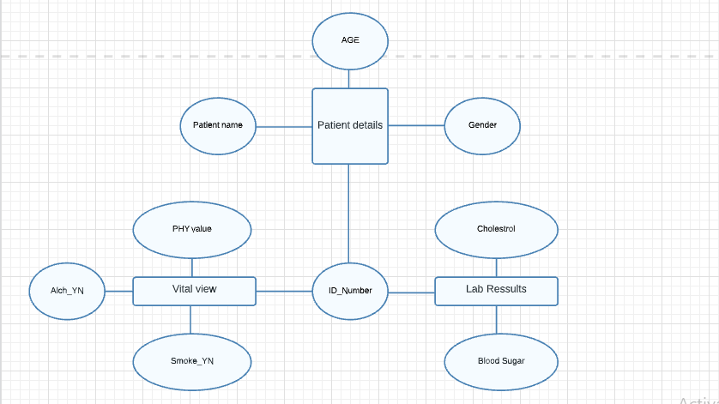
Fig: 2.10.1 ER Diagram

Use case Diagram:

As the most known diagram type of the behavioral UML types, Use case diagrams give a graphic overview of the actors involved in a system, different functions needed by those actors and how these different functions interact.

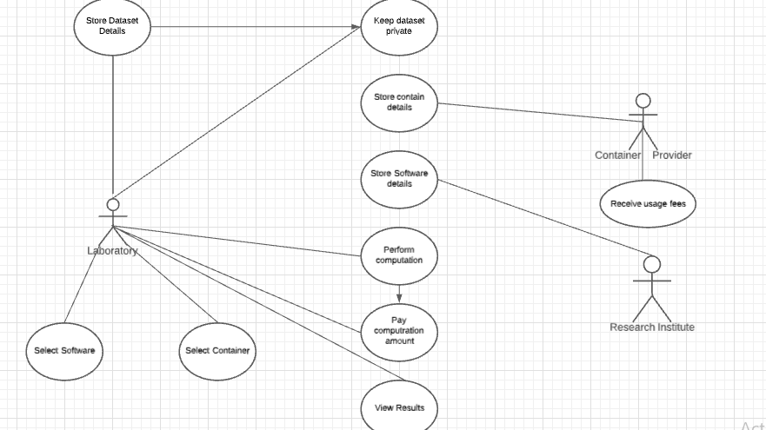

Fig: 2.10.2 Use case diagram

Class Diagram:

Class diagrams are the main building block of any object-oriented solution. It shows the classes in a system, attributes, and operations of each class and the relationship between each class.
In most modeling tools, a class has three parts. Name at the top, attributes in the middle and operations or methods at the bottom. In a large system with many related classes, classes are grouped together to create class diagrams. Different relationships between classes are shown by different types of arrows.

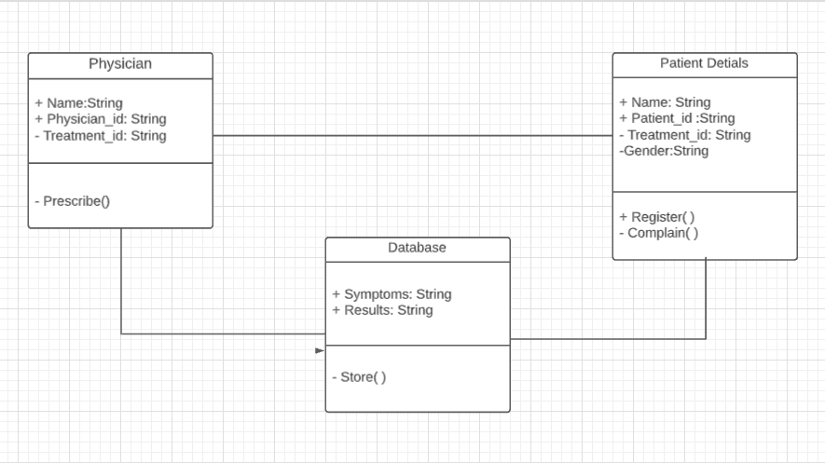
Fig.2.10.3 Class diagram

Sequence Diagram:

Sequence diagrams in UML show how objects interact with each other and the order those interactions occur. It’s important to note that they show the interactions for a particular scenario. The processes are represented vertically and interactions are shown as arrows.

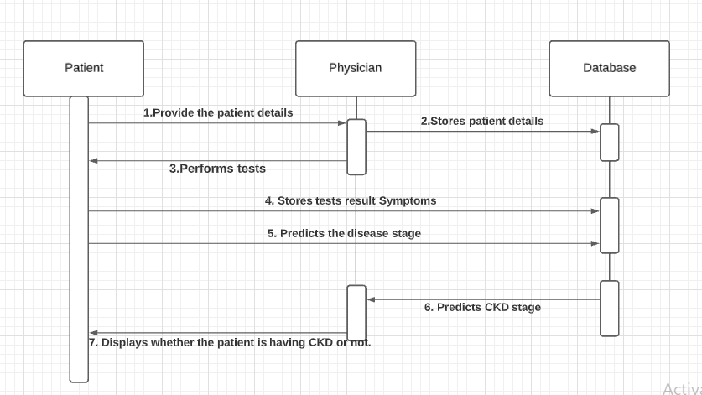
Fig.2.10.4 Sequence diagram

3. Proposed Methodology

The proposed architecture for the chronic kidney disease prediction model is depicted in below fig consisting of various sub-modules which include: Data-preprocessing, model building and testing, ensemble model prediction and performance evaluation. Each module shows a different role they played towards the overall accuracy of a predictive model. The rest of this work is structured in respect with the proposed chronic kidney prediction architecture.

BLOCK DIAGRAM

Raw data
Data Pre-Processing

Missing values
Split data
Data scaling
PSO
PCA
Models building

Training set
Naive Bayes
K-Nearest Neighbours
Decision Tree
P1
P2
P3
Ensemble Models
Predict the ideal classifier with best accuracy rate for this model
P4

Fig.3. Block diagram

3.1 Addressing Issues

- Among Naive-bayes, Decision Tree and KNN, predicting the best classifiers with ensemble techniques.

- Data containing NaN values and inserting NaN values could be solved.

- By using PCA can visualise the reduced dimensions.

3.2 Proposed Methodology

Data Pre-Processing

Handling Missing values:

The CKD data set that we are using was found to contain a substantial occurrence of missing values across the individual features. eliminating samples or features that have missing values is simply not feasible because valuable information in it may be lost in the process. backfill technique in which the value next to the missing or not available number was used to fill the missing data.

PSO (Particle Swarm Optimisation)

Particle Swarm Optimisation is a computation method that optimises a problem by iteratively trying to improve a candidate solution with regard to a given measure of quality. Here we optimised the particles that are 25 attributes to the best 2 particles. This is expected to move the Swarm towards the best solution.

PCA (Principal Component Analysis)

Principal component analysis (PCA) is a technique for reducing the dimensionality of such datasets, increasing interpretability but at the same time minimising information loss. We found the new uncorrelated variables and found the best variable analysis results among the 25 attributes.

Classifiers

Naive Bayes:

The Naïve Bayes algorithm is a supervised learning algorithm, which is based on Bayes theorem and used for solving classification problems.

- It is mainly used in text classification that includes a high-dimensional training dataset.
- The Naïve Bayes Classifier is one of the simplest and most effective Classification algorithms which helps in building the fast machine learning models that can make quick predictions.
- It is a probabilistic classifier, which means it predicts on the basis of the probability of an object.

- Bayes' theorem is also known as Bayes' Rule or Bayes' law, which is used to determine the probability of a hypothesis with prior knowledge. It depends on the conditional probability.
- The formula for Bayes' theorem is given as:
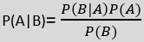

Where,
P(A|B) is Posterior probability: Probability of hypothesis A on the observed event B.
P(B|A) is Likelihood probability: Probability of the evidence given that the probability of a hypothesis is true.
P(A) is Prior Probability: Probability of hypothesis before observing the evidence.
P(B) is Marginal Probability: Probability of Evidence.

Decision Tree:

Decision tree uses divide and conquer approach to construct decision rules for solving classification problems using information gain ratio which avoid the bias of. The goal of prediction using the decision tree algorithm used to learn a mapping function from input variable X to output variable C.

Decision tree makes its classification using information gain which is the measure of the differences in entropy from before to after the current set S for which entropy is calculated is split on an attribute A. therefore in order to make classification that attribute with the highest information gain is seen as the best classifier for making decisions and this is calculated as:
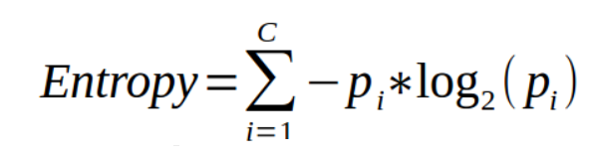

Information gain:

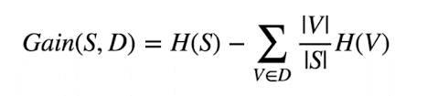

K-nearest neighbour (KNN)

The k-nearest neighbour classifier is a non-parametric classifier used to classify an unknown instance represented by some feature vectors as a point in the features space that measures the distance between two data points in the training data set. KNN uses matrices such as Euclidean distance, Minkowski distance and Manhattan distance as a metric system.The research used minkowski distance as the distance metric for classified the nearest distance, expressed as:

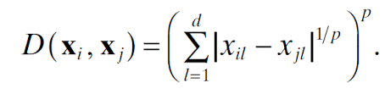

Bagging:

The approach bagging used in the study for combining base classifiers performance is a multi-algorithm approach that improves the stability of the classification accuracy. The basic idea of bagging is to aggregate the predictions generated from classifiers KNN, naive bayes and decision tree using a bootstrap sample of training data to generate new hypotheses. Bootstrap sample is generated by sampling D instances from the training set samples with replacement. During the bagging ensemble process, The base learners KNN, Naive bayes, and decision tree Used in this study are trained and built from each bootstrap sample of the original CKD data set and their predictions are combined the with bagging ensemble using majority voting method to form a consensus model for making Final Decision used in classification. it can be determined by:

Cf = arg max i m i=1 J ryi
and J ryi = 1, i f jr = yi 0, i f jr = yi
Where Jr represents the decision of the rth classifier given class yi, Cf represents final prediction.

Random subspace:

The Random subspace ensemble known as attribute bagging is an ensemble technique that constructs classifiers (KNN, Naïve Bayes and Decision tree) based on different Attributes/features. It is a similar approach to bagging except that it randomly chooses a subset of features from the original dataset with replacement and then learns the base model depending only on these features .This approach allows the individual learners not to over focus on attributes that are highly predictive in the training set. This ensemble generalises well when there are redundant features in the dataset.

4. Results and discussion

4.1 Dataset

In this system, we are using a CSV file dataset. Dataset consists of 400 instances with 25 different attributes having 11 numeric and 14 nominal values which are parameters of the health test results. The dataset obtained on Kaggle was noisy and required cleaning.

The dataset is made of two classes’ non CKD and CKD relating to the patients without Chronic Kidney disease and with Chronic Kidney Disease.

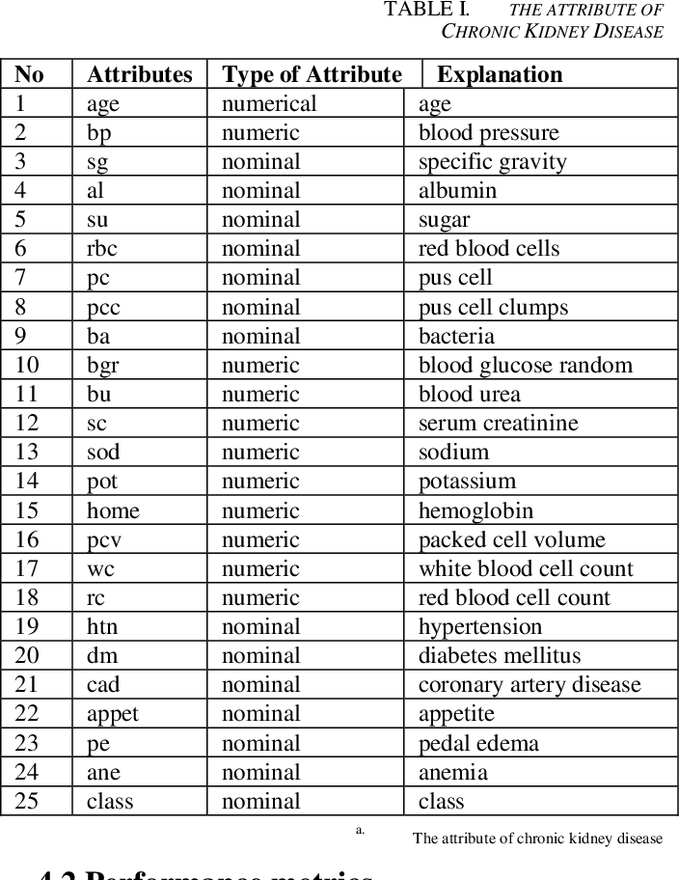
Fig.4.1. Dataset of 25 attributes

4.2 Tools and Languages

- Python

Python is an interpreted, high-level, general-purpose programming language. Created by Guido van Rossum and first released in 1991, Python design philosophy emphasises code reliability with its notable use of significant whitespace. Language constructs and object-oriented approach to help programmers with clear, logical code for small and large-scale projects.

Python is dynamically typed and garbage collected. It supports multiple Programming Paradigms, including procedural, Object oriented, and functional programming.Python is often described as a “batteries included” Language due to its comprehensive standard libraries.

- SKLEARN

It is a library that is available for python that provides many algorithms including both supervised and unsupervised learning algorithms. This library Depends upon the NumPy and Pandas. It provides several functionalities like linear regression classification, pre-processing and clustering algorithms.

- NUMPY

The abbreviation of NumPy is numerical python. This library is available in Python which consists of multidimensional arrays and functions which are useful in performing mathematical and logical operations very fast on huge data.

- PANDAS

It is a popular library that is used for data science and data structures that are used for data manipulation and data analysis. Pandas name is derived from “Panel data” which means the multidimensional Structured data sets. Pandas is open source and available free to everyone.

4.3 Performance Metric

Confusion Matrix

It is the easiest way to measure the performance of a classification problem where we predicted for each classifier individually for better predictions. For the 3 classifiers we made a confusion matrix table with two dimensions viz. “Actual” and “Predicted” and furthermore, both the dimensions have “True Positives (TP)”, “True Negatives (TN)”, “False Positives (FP)”, “False Negatives (FN)”

- True Positives (TP) − It is the case when both actual class & predicted class of data point is 1.
- True Negatives (TN) − It is the case when both actual class & predicted class of data point is 0.
- False Positives (FP) − It is the case when the actual class of data point is 0 & predicted class of data point is 1.
- False Negatives (FN) − It is the case when the actual class of data point is 1 & predicted class of data point is 0.

Sensitivity:
Here we measured the proportion of the patient's kidney with chronic kidney disease.
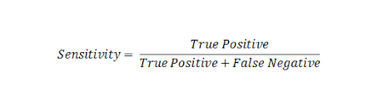

Specificity:

It measures the proportion of the patient without chronic kidney disease.

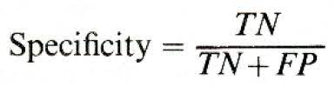

Accuracy:

It reflects the number of correctly classified predictions from all predictions made.

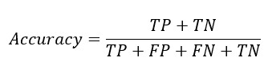

4.4 Discussion on Result

Here, visualisations of individual base classifiers, bagging and Random space ensemble performed. The confusion matrix for each classifier among all KNN being a fast training and robust algorithm shows the best classification performance with the highest accuracy of 88% than other individual classifiers used in the study on 25 attributes of chronic kidney disease dataset. The ensemble techniques employed in this project shows the effectiveness of multi-classifiers in aggregating base learners prediction having better classification results than the individual based classifier performances at all levels.

The performance of random subspace ensemble technique and KNN classifier resulted in the best accuracy of 88%, then the result obtained using bagging combined with the same base learner on 25 attributes of Chronic kidney disease dataset. The high performance of the developed ensemble approach to chronic kidney disease diagnosis can be attributed to the ensemble method involved in training the base classifiers which combines the predictive power of the base classifiers.

Now lets see the code snippets for all phases how we implemented them to obtain the best accuracy for predicting the CKD.

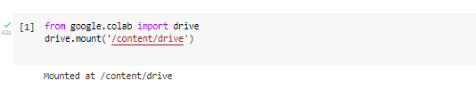Fig.4.4.1 Mount the content to drive

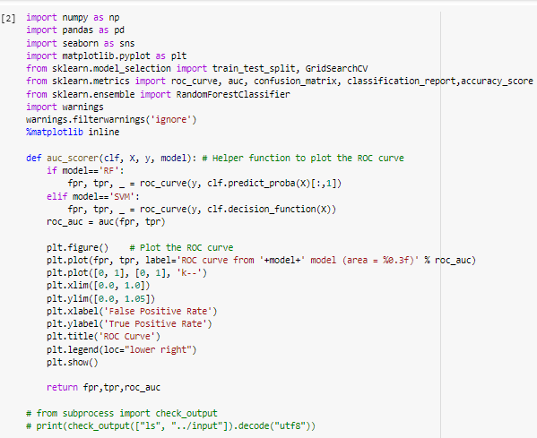

Fig: 4.4.2 Loading all the modules and helper functions

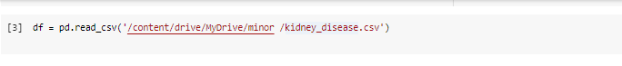
Fig.4.4.3 Reading the dataset

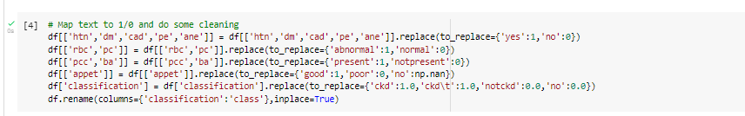

Fig.4.4.4 Basic cleaning of the data.

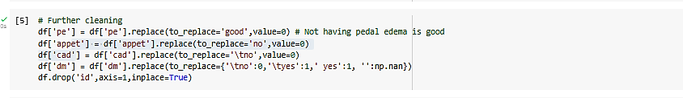

Fig.4.4.5 Future cleaning by checking the type of the value

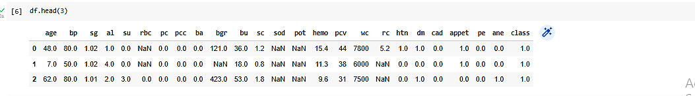

Fig.4.4.6 Checking data by calling the first 3 rows of the dataset.

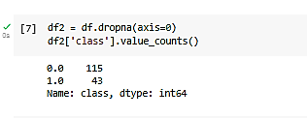

Fig.4.4.7 Checking No.of NaN values and dropping them from all the rows
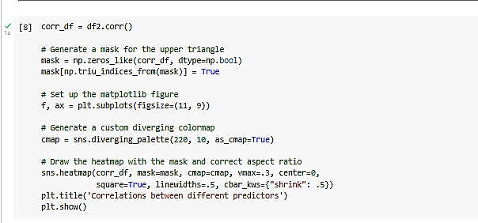

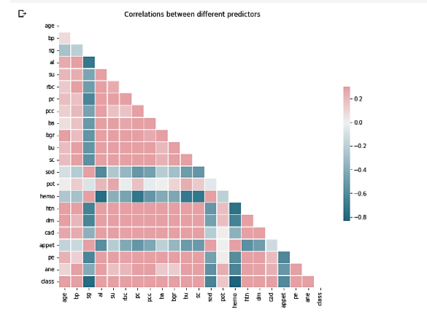

Fig.4.4.8 Examine correlation between different features

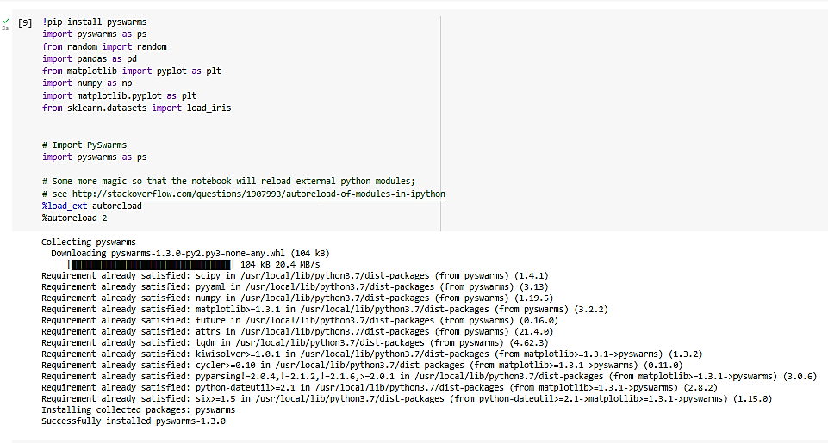

Fig.4.4.9 Importing PySwarms for PSO

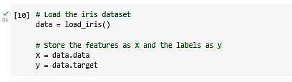

Fig.4.4.10Storing features as X and Y labels

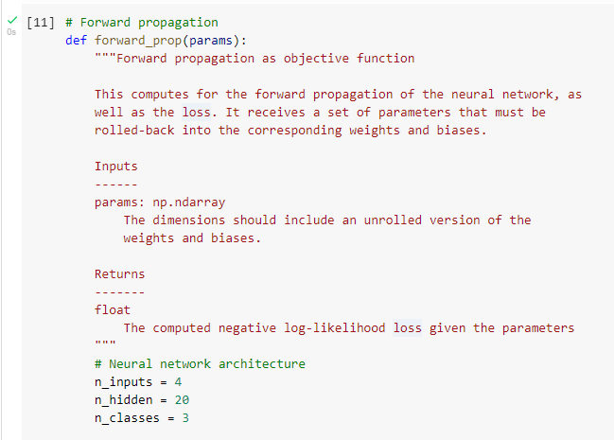
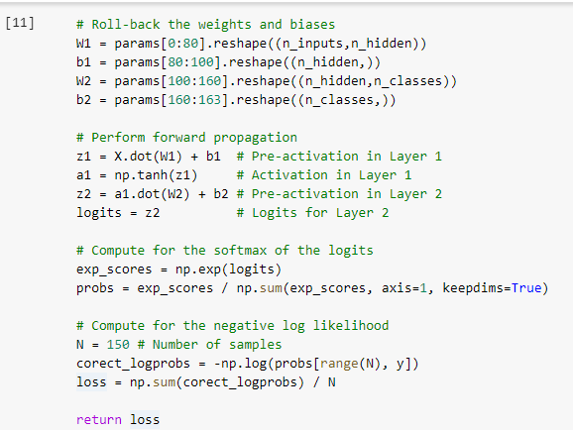

Fig.4.4.11 Forward Propagation

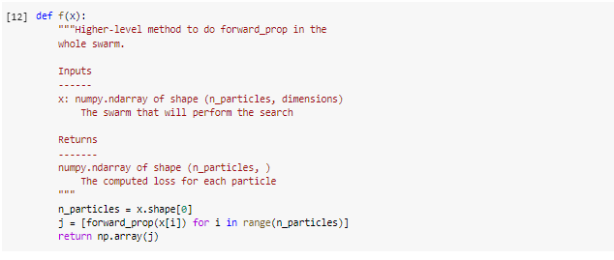

Fig.4.4.12 Higher propagation for swarm

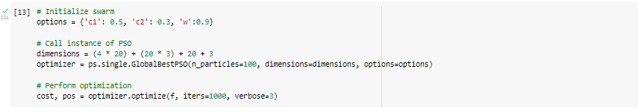
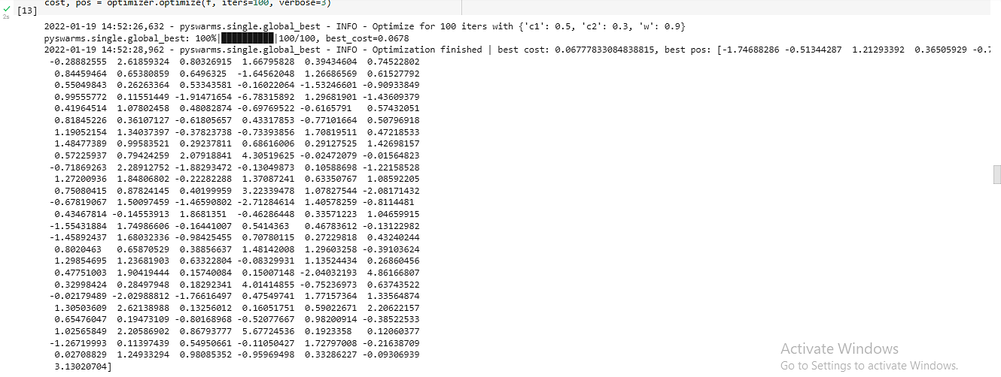

Fig.4.4.13 Performing Optimization

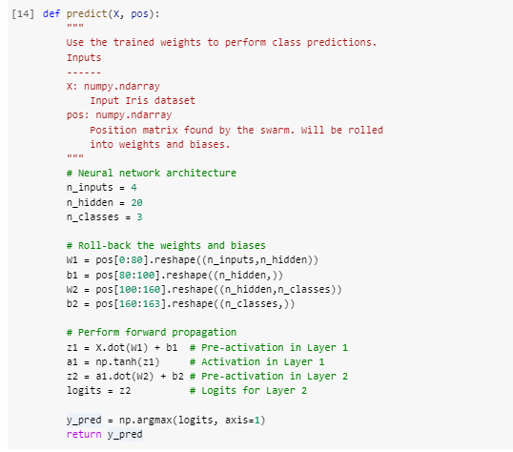
Fig.4.4.14 PSO

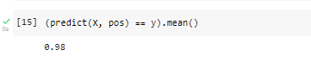
Fig.4.4.15 PSO Optimization
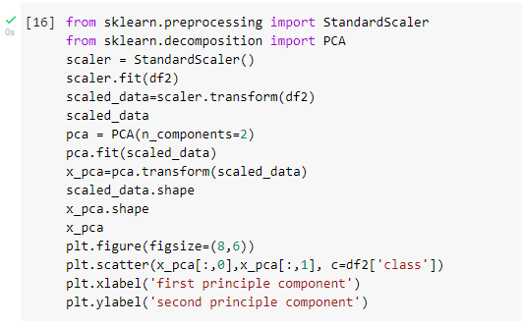
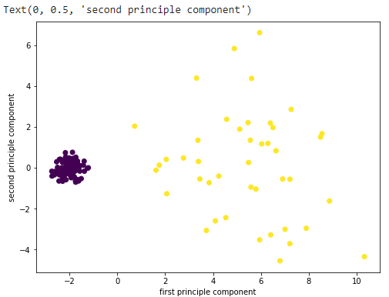

Fig.4.4.16 PCA

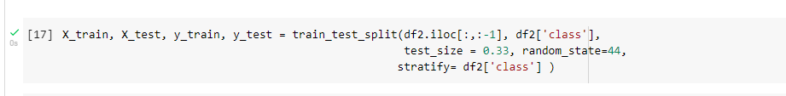

Fig.4.4.17 Splitting X and Y values

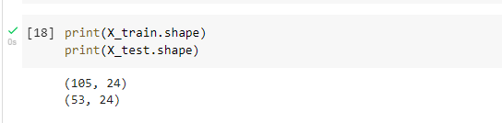

Fig.4.4.18 Training and Testing X values

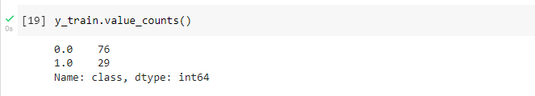

Fig.4.4.19 Training and testing Y values
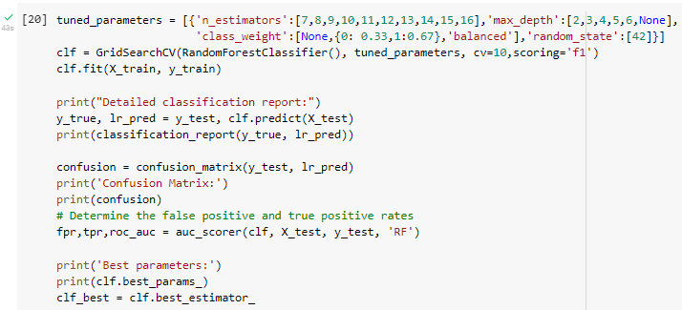
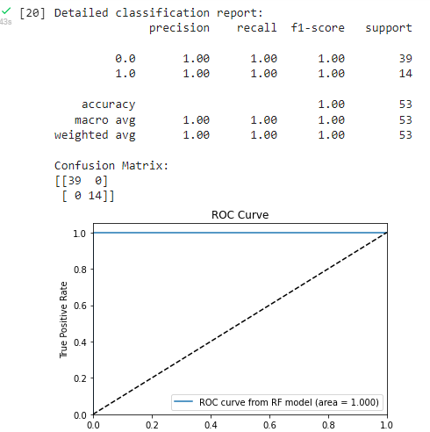

Fig.4.4.20 Parameter Classification
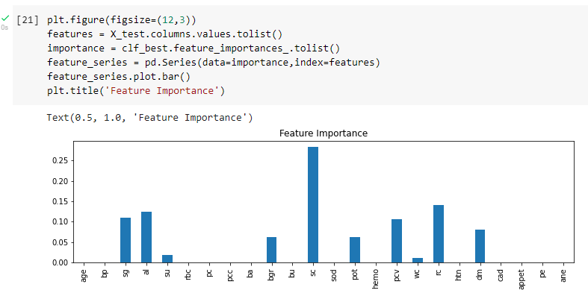

Fig.4.4.21 Feature Classification

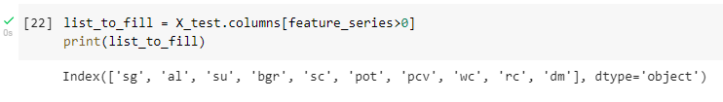

Fig.4.4.22 Features Extraction
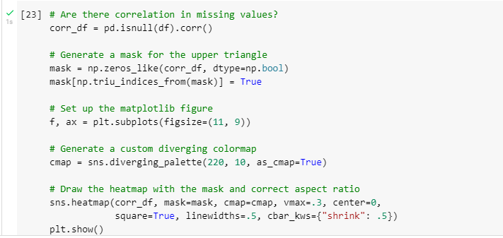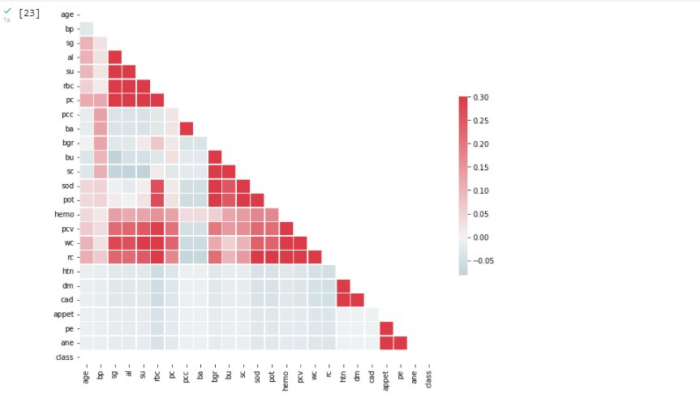
Fig.4.4.23 Plotting the attributes

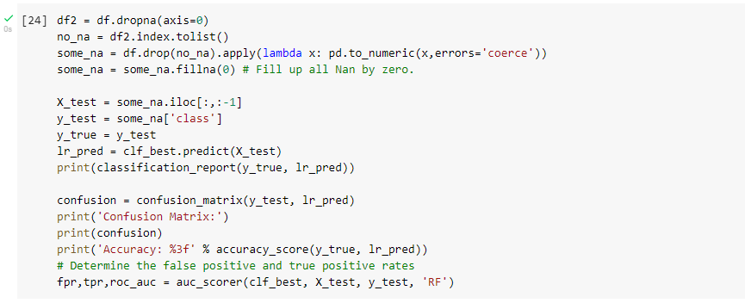
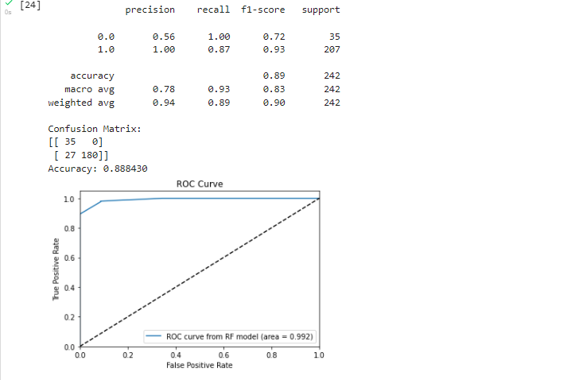
Fig.4.4.24 F1-Score Accuracy rate

5. Conclusion

The prevalence of chronic kidney disease in the world today is worrisome which is seen as a major threat to human life. This paper presents three base learners and two ensemble techniques to improve its classification accuracy for efficient diagnosis of chronic kidney disease. Since human lives are directly involved, accuracy of such a model is of high priority. The use of ensemble learning approaches to aggregate the output of various data mining models (Naïve Bayes, KNN and Decision tree classifier) is demonstrated in this research over chronic kidney disease dataset as one of the measures by which classification accuracy of these computer aided diagnostic models could be improved. The proposed method was implemented using python programming language. The performance of the proposed model was evaluated and comparisons were made among individual learner and ensemble models. Experimental results revealed that the developed ensemble approach to chronic kidney disease diagnosis outperformed individual classification algorithms in terms of performance with the best classification accuracy of 1.00 accuracy, 1.00 sensitivity, 1.00 specificity, 1.00 kappa value and 1,00 ROC value as shown in Table 6 obtained from Random subspace with KNN classifier. It also outperformed results obtained from bagging ensembles. Observable results from the study revealed that ensemble approach gives a better prediction than individual base classifiers hence suitable for chronic kidney disease predictions.

References

